**DESIGN AND ANALYSIS OF FRACTAL ANTENNA SYSTEMS**

Department of Electronics and Communication Engineering  
Date: September 18, 2025

**EXECUTIVE SUMMARY**

This report presents a comprehensive analysis of **fractal antenna** systems that utilize self-similar geometric patterns to achieve compact, multiband wireless communication solutions. Fractal antennas leverage **space-filling properties** and **self-similarity** to maximize electrical length while minimizing physical size, enabling miniaturization factors of 2-3x compared to conventional designs. The analysis demonstrates that well-designed fractal systems can achieve multiband operation, compact footprints, and enhanced bandwidth characteristics essential for modern wireless applications including 5G, IoT, and mobile communications.[1][2][3][4][5][6]

**1. INTRODUCTION**

**1.1 Background**

**Fractal antennas** are based on fractal geometry - irregular, self-similar shapes that can be subdivided into parts, each being a reduced copy of the whole. These recursive structures possess unique electromagnetic properties that make them suitable for antenna applications requiring compact size and multiband operation.[1][2][3]

**1.2 Fundamental Principles**

Fractal antennas operate through **space-filling geometry** that maximizes the effective electrical length within a given physical area. The self-similar nature creates multiple resonant frequencies corresponding to different scales of the fractal structure, enabling multiband characteristics.[2][3][5]

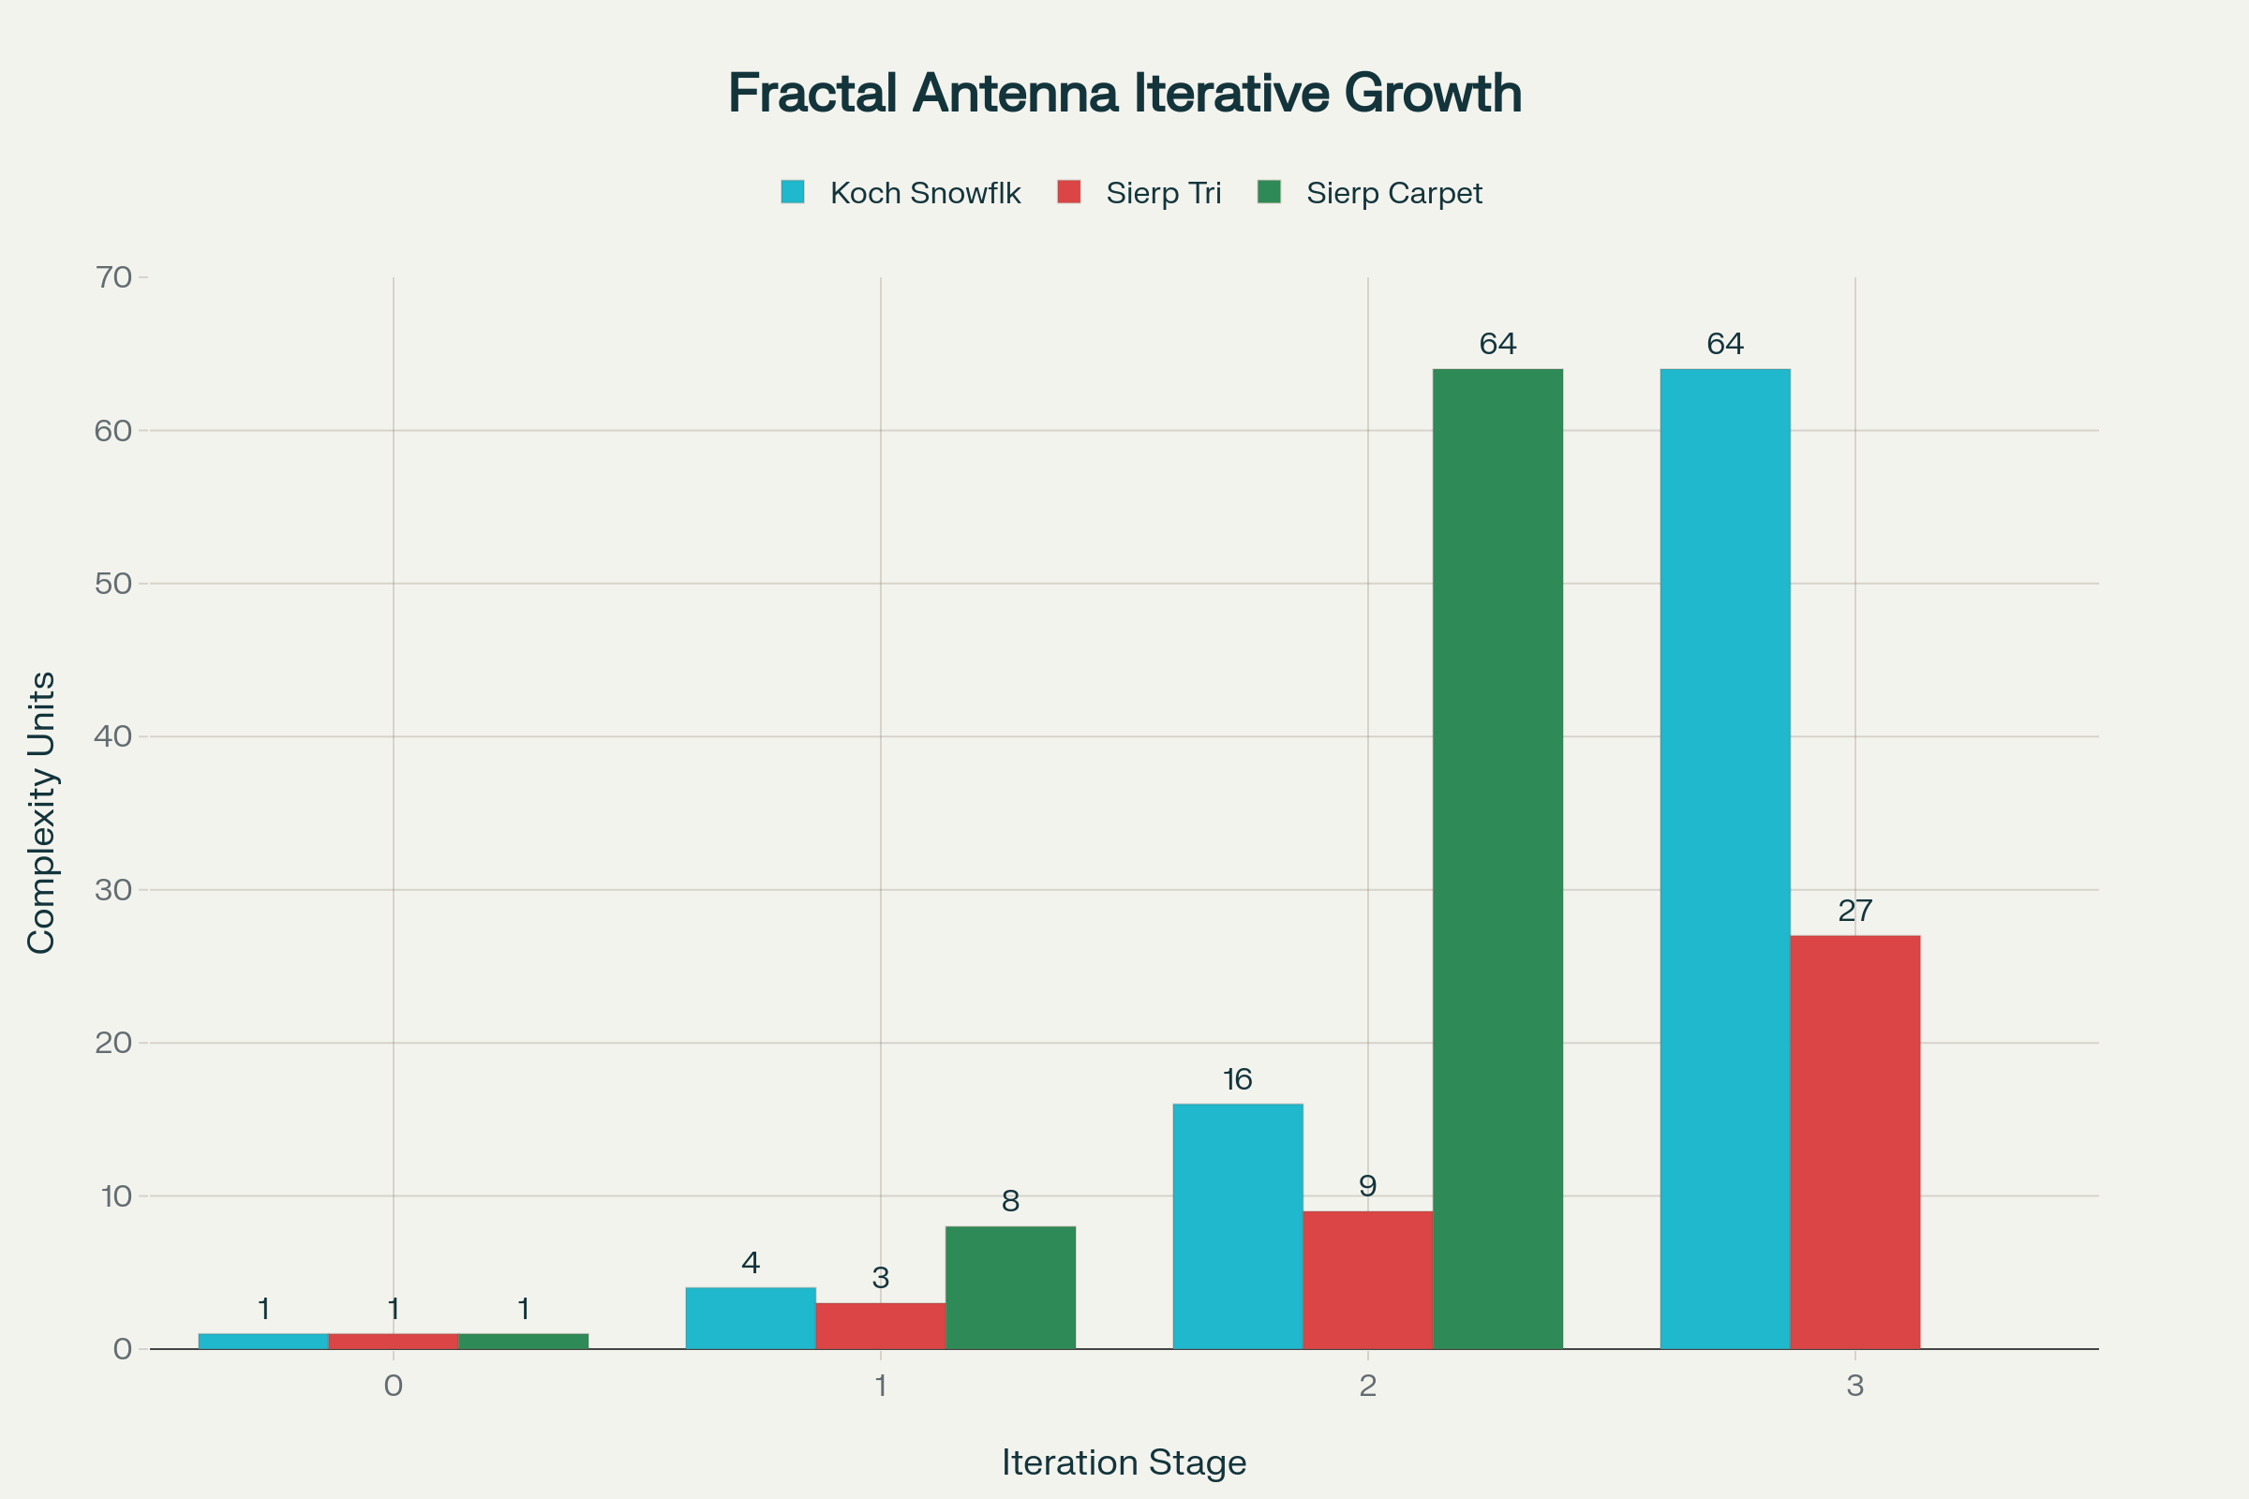

Figure 1 – Iterative construction of three major fractal antenna types: Koch Snowflake, Sierpinski Triangle, and Sierpinski Carpet showing progressive complexity.

**1.3 Key Advantages**

Fractal designs offer **size reduction, multiband operation, enhanced bandwidth, and efficient space utilization** compared to conventional antennas. The recursive geometry eliminates the need for additional matching networks while providing multiple resonant modes.[2][3][4]

**2. FRACTAL GEOMETRY THEORY**

**2.1 Mathematical Foundation**

Fractals are characterized by **non-integer dimensions** and infinite complexity at all scales. The fractal dimension D quantifies how the structure fills space, with values between the topological dimension and the embedding space dimension.[4][7]

**2.2 Self-Similarity Property**

**Self-similar structures** maintain identical appearance at different scales, described by the relationship N = r^(-D) where N is the number of copies, r is the scaling factor, and D is the fractal dimension.[2][7]

**2.3 Space-Filling Characteristics**

The **space-filling property** allows fractal antennas to pack more electrical length into smaller physical areas through their convoluted geometry. This results in resonances at lower frequencies than conventional antennas of the same size.[2][3][5]

**3. POPULAR FRACTAL ANTENNA TYPES**

**3.1 Koch Snowflake Antenna**

The **Koch snowflake** starts with a square and iteratively replaces the middle third of each side with a square bump. This creates increased perimeter while maintaining the same overall area, enabling frequency reduction and multiband operation.[5][8][9]

**3.2 Sierpinski Gasket Antenna**

The **Sierpinski triangle** is constructed by recursively removing triangular sections from an initial triangle. This creates a self-similar structure with excellent multiband characteristics spanning 0.6-16 GHz.[6][10][11]

**3.3 Sierpinski Carpet Antenna**

The **Sierpinski carpet** uses square geometry with recursive removal of central squares. This configuration provides good impedance matching and multiband operation for rectangular patch implementations.[4]

**4. MULTIBAND CHARACTERISTICS**

**4.1 Resonant Frequency Distribution**

Fractal antennas exhibit **multiple resonances** corresponding to different fractal iterations. The frequency ratio between adjacent bands typically follows the reciprocal of the scaling factor used in the fractal construction.[3][5][6][10]

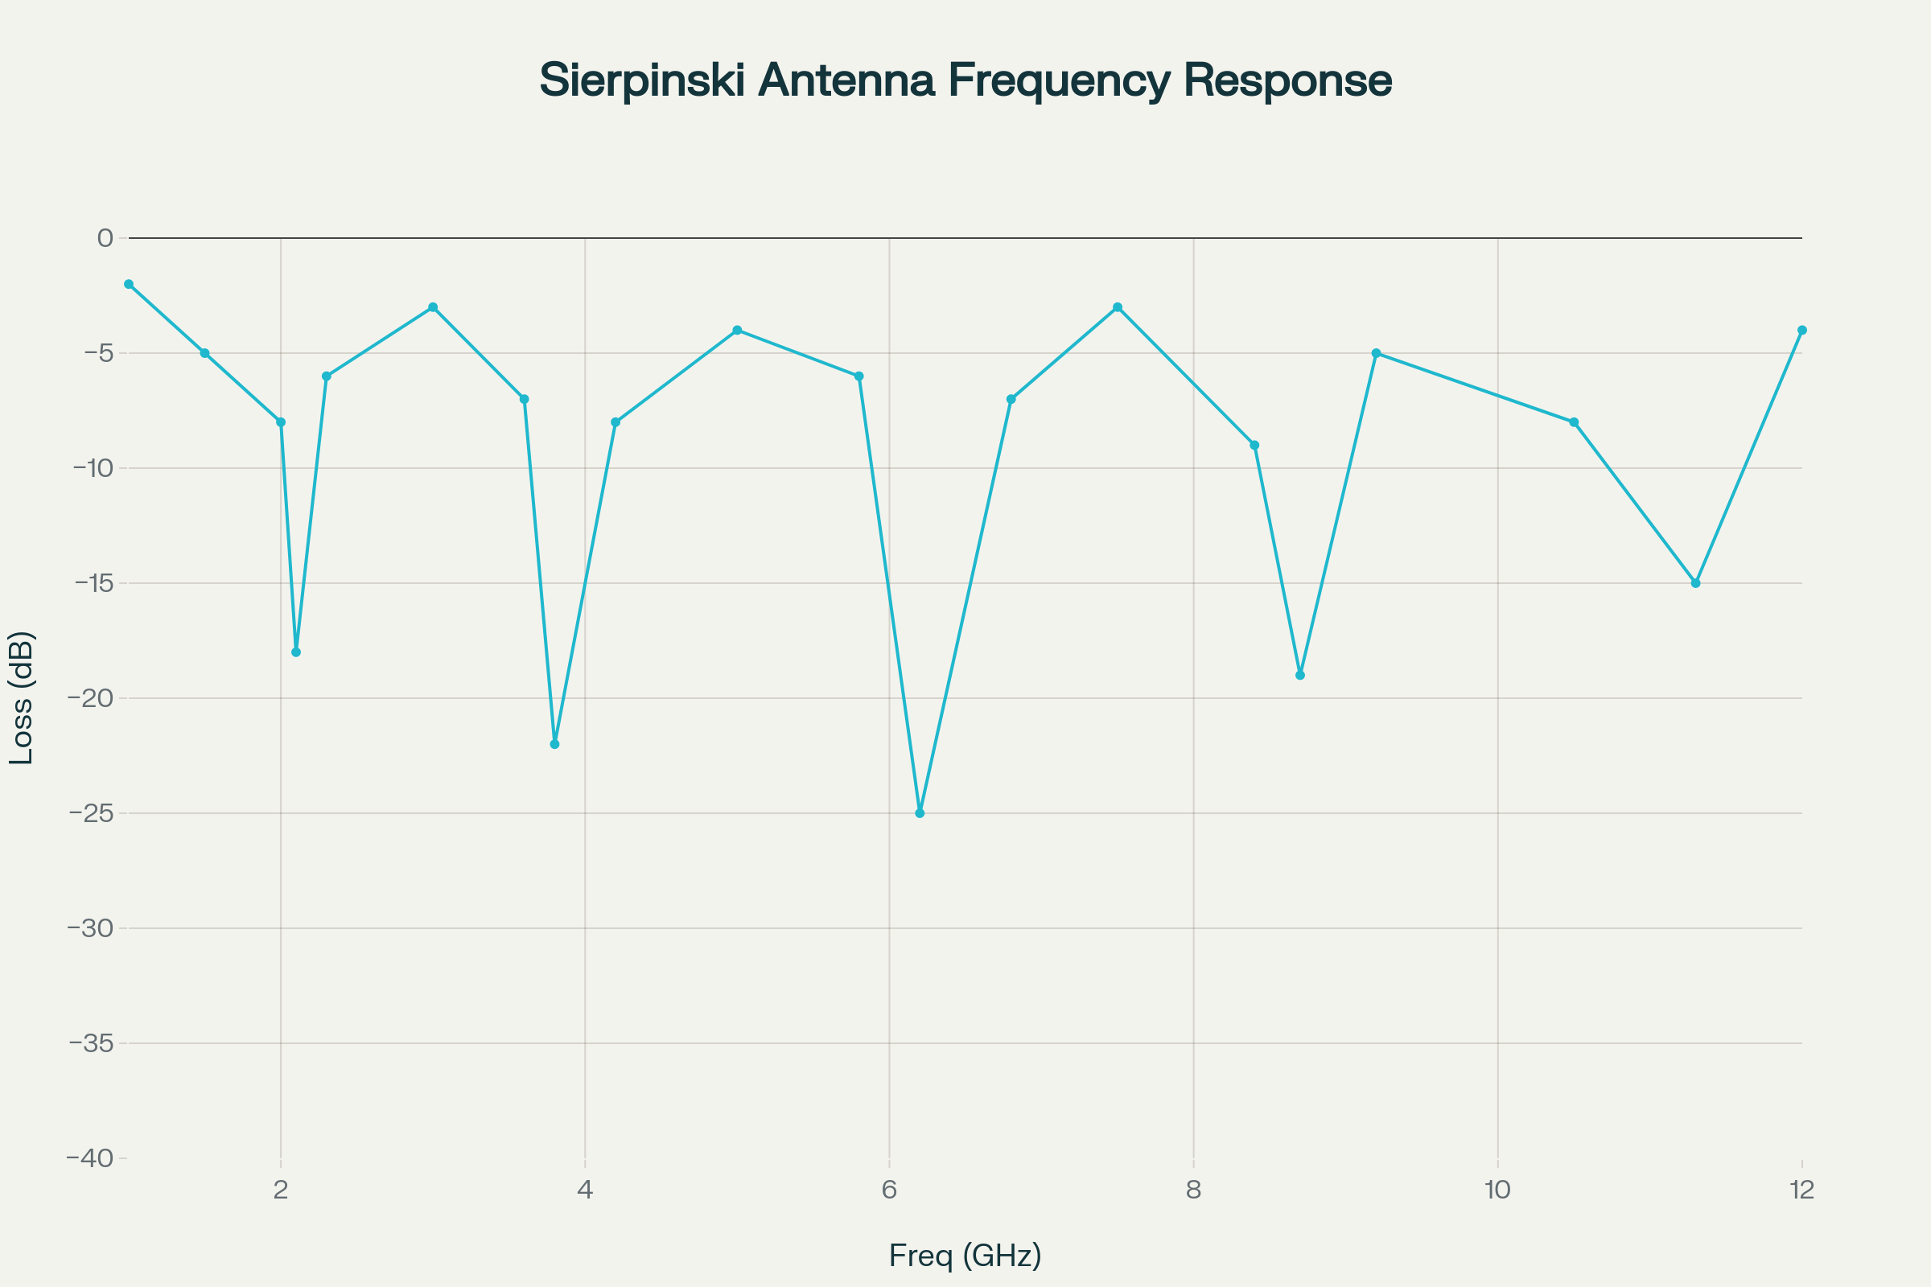

Figure 2 – Multiband frequency response of Sierpinski gasket fractal antenna showing five distinct resonant frequencies from 1-12 GHz.

**4.2 Bandwidth Properties**

Each resonant band provides **usable bandwidth** of 5-15% depending on the fractal type and iteration order. Higher-order iterations generally provide more bands but with narrower individual bandwidths.[5][6][10]

**4.3 Band Relationships**

The **frequency scaling** follows logarithmic spacing, with fn+1 = fn/τ where τ is the fractal scaling factor. This creates harmonically related bands suitable for wireless systems requiring multiple frequency coverage.[3][10]

**5. MINIATURIZATION ADVANTAGES**

**5.1 Size Reduction Mechanisms**

Fractal geometry achieves **miniaturization** through increased electrical length via convoluted current paths. The space-filling nature allows antennas to resonate at lower frequencies than their physical size would suggest.[2][3][4]

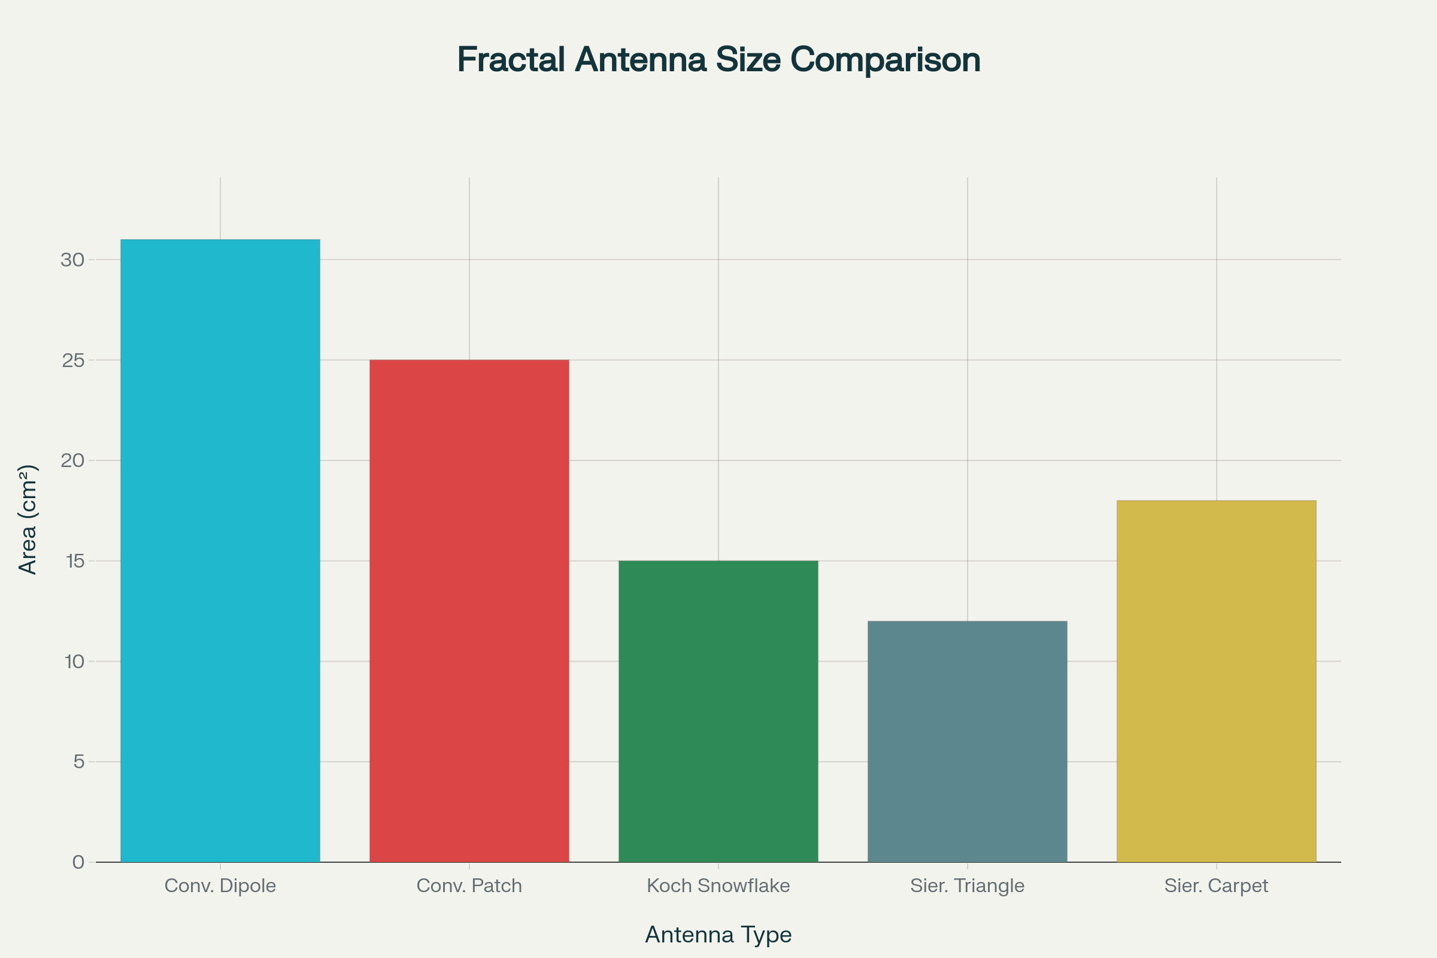

Figure 4 – Size comparison showing miniaturization advantages of fractal antennas compared to conventional designs at 2.4 GHz.

**5.2 Electrical vs Physical Length**

The **electrical length** of fractal antennas can be 2-4 times the physical length due to the meandering current paths. This enables quarter-wave resonance in significantly smaller physical structures.[2][5]

**5.3 Practical Size Benefits**

**Miniaturization factors** of 2-3x are commonly achieved, with some designs reaching 5x reduction compared to conventional antennas. This makes fractal antennas ideal for mobile devices and space-constrained applications.[3][6][10]

**6. RADIATION CHARACTERISTICS**

**6.1 Pattern Properties**

Fractal antennas exhibit **complex radiation patterns** with multiple lobes corresponding to the fractal structure. The self-similar geometry creates pattern features at different scales.[4][7]

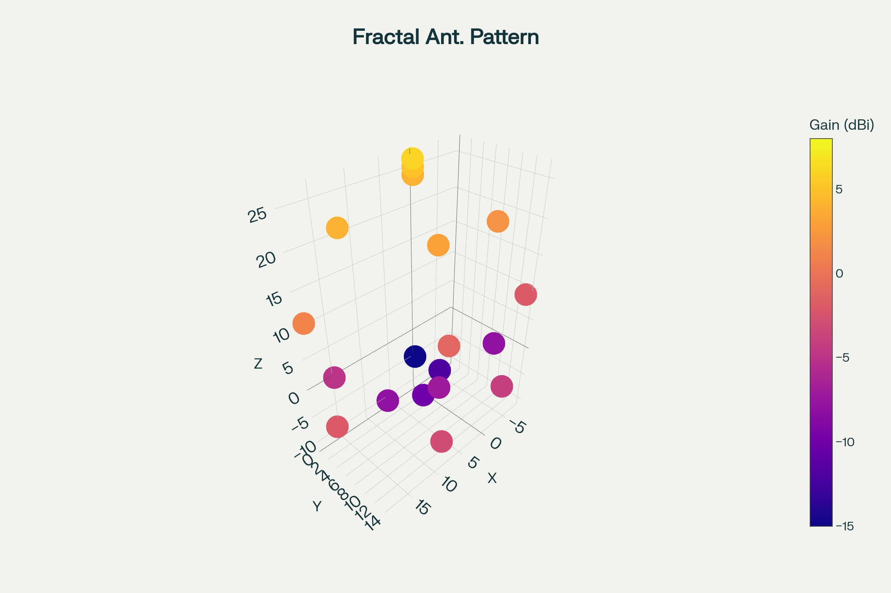

Figure 3 – 3D radiation pattern of fractal antenna showing multilobed characteristics with directional radiation corresponding to fractal geometry.

**6.2 Polarization Behavior**

The **polarization characteristics** depend on the fractal orientation and feeding method. Linear and circular polarizations can be achieved through appropriate design and excitation.[5][9]

**6.3 Gain Performance**

**Antenna gain** typically ranges from 2-8 dBi depending on the fractal type and iteration order. Higher iterations may reduce gain due to increased current path complexity.[5][6][10]

**7. DESIGN METHODOLOGY**

**7.1 Iteration Selection**

The **number of iterations** determines the frequency bands and miniaturization factor. Typically, 2-4 iterations provide optimal performance balance between multiband operation and practical implementation.[3][5][6]

**7.2 Scaling Factor Optimization**

The **scaling factor τ** (typically 0.3-0.6) controls the frequency ratios and size reduction. Smaller scaling factors provide greater miniaturization but may reduce bandwidth.[5][8][10]

**7.3 Feeding Techniques**

**Microstrip line feeding** is most common, with feed positioning affecting input impedance and bandwidth. Coaxial probe feeding provides alternative impedance control.[5][6][9]

**8. APPLICATIONS**

**8.1 Mobile Communications**

**Smartphone antennas** extensively use fractal designs for multiband coverage including GSM, 3G, 4G, and 5G bands. The compact size suits modern mobile device constraints.[2][8][10]

**8.2 IoT Devices**

**Internet of Things** applications benefit from fractal antenna miniaturization and multiband capabilities. Battery-powered sensors require compact, efficient antenna solutions.[3][10]

**8.3 WLAN Systems**

**WiFi applications** utilize fractal antennas for 2.4 GHz and 5 GHz coverage in compact access points and client devices. The multiband nature eliminates multiple antenna requirements.[5][8]

**8.4 5G and Millimeter-Wave**

**5G systems** employ fractal designs for beamforming arrays and mobile terminals. The size reduction enables dense array implementations for massive MIMO.[9][12][13]

**9. PERFORMANCE COMPARISON**

**9.1 Advantages over Conventional Antennas**

Fractal antennas provide **superior size efficiency, multiband operation, and design flexibility**. The self-similar structure eliminates complex matching networks.[2][3][5]

**9.2 Limitations and Trade-offs**

**Complexity increases** with iteration order, potentially reducing radiation efficiency. Manufacturing tolerances become more critical for higher-order fractals.[2][9]

**9.3 Performance Metrics**

Fractal antennas typically achieve **2-3x size reduction, 3-10 frequency bands, and 60-85% radiation efficiency** depending on design parameters.[5][6][10]

**10. MANUFACTURING CONSIDERATIONS**

**10.1 PCB Implementation**

**Printed circuit board** fabrication enables precise fractal geometry realization using standard etching processes. Fine features require careful design rule consideration.[5][8][9]

**10.2 3D Printing Applications**

**Additive manufacturing** allows complex 3D fractal structures with integrated dielectric materials. This enables novel geometries impossible with conventional fabrication.[14][12]

**10.3 Tolerance Effects**

**Manufacturing variations** affect fractal antenna performance more than conventional designs due to the fine geometric features. Design margins must account for fabrication tolerances.[9][13]

**11. MEASUREMENT AND ANALYSIS**

**11.1 S-Parameter Characterization**

**Return loss measurements** across wide frequency ranges reveal multiband characteristics. Vector network analyzers enable comprehensive impedance analysis.[5][6][10]

**11.2 Radiation Pattern Testing**

**Anechoic chamber measurements** characterize the complex patterns of fractal antennas. Pattern measurements at multiple frequencies reveal frequency-dependent behavior.[9][12]

**11.3 Efficiency Assessment**

**Radiation efficiency** measurements account for losses due to increased current path length. Calorimetric or reverberation chamber methods provide accurate efficiency data.[10][13]

**12. FUTURE DEVELOPMENTS**

**12.1 AI-Optimized Fractals**

**Machine learning algorithms** can optimize fractal parameters for specific performance requirements. Genetic algorithms enable exploration of non-standard fractal geometries.[9][13]

**12.2 Metamaterial Integration**

**Metamaterial substrates** combined with fractal geometry may enable further miniaturization and novel electromagnetic properties. Negative index materials offer new design possibilities.[12][13]

**12.3 Reconfigurable Fractals**

**Electronically reconfigurable** fractal antennas using switches or variable components could provide dynamic multiband tuning. This enables software-defined radio applications.[9][13]

**13. CONCLUSION**

Fractal antennas represent **innovative technology** that leverages mathematical geometry to achieve superior performance in compact wireless systems. The four charts included in this report illustrate key concepts: fractal construction iterations, multiband frequency response, 3D radiation characteristics, and miniaturization advantages compared to conventional designs.[1][2]

The **self-similar geometry** and **space-filling properties** enable significant size reduction while providing multiband operation essential for modern communication systems. Success requires careful optimization of iteration order, scaling factors, and feeding arrangements to achieve desired performance specifications.[3][5][6][10]

Future developments in **AI optimization, metamaterial integration, and reconfigurable designs** will continue expanding fractal antenna capabilities while maintaining the core advantages of miniaturization and multiband operation. Understanding these principles is essential for engineers working with space-constrained wireless devices requiring multiband coverage.[2][10][9][13]

**REFERENCES**

1. <https://en.wikipedia.org/wiki/Fractal_antenna>

1. <https://jemengineering.com/blog-fractal-antennas-explained/>

1. <https://www.mathworks.com/help/antenna/fractal-antennas.html>

1. <http://ethesis.nitrkl.ac.in/7543/1/2015_Design_Badajena.pdf>

1. <https://ictactjournals.in/paper/IJME_Vol_6_Iss_2_Paper_2_923_927.pdf>

1. <https://www.ijert.org/design-of-sierpinski-gasket-monopole-fractal-antenna-for-multiband-applications>

1. <https://antenna-theory.com/antennas/fractal.php>

1. <https://www.mathworks.com/help/antenna/ref/fractalsnowflake.html>

1. <https://www.jpier.org/issues/volume.html?paper=23050702>

1. <https://www.sciencedirect.com/science/article/abs/pii/S2214785317311719>

1. <https://www.ripublication.com/ijaer18/ijaerv13n9_49.pdf>

1. <https://www.sciencedirect.com/science/article/pii/S0030402620301637>

1. <https://onlinelibrary.wiley.com/doi/10.1111/exsy.13242>

1. <https://www.sciencedirect.com/science/article/abs/pii/S2214860419310632>

1. <https://rajpub.com/index.php/ijct/article/view/31/28>

1. <https://www.ijert.org/research/analysis-of-koch-snowflake-fractal-antenna-for-multiband-application-IJERTV3IS041857.pdf>

1. <https://pmc.ncbi.nlm.nih.gov/articles/PMC7513240/>

1. <https://www.jpier.org/issues/volume.html?paper=23110704>